BIT3208: Advanced Web Design and Development
Logbook report
Student Details
Student Name: Murege Lucy Wanjiru
Admission Number: BBIT/2024/73585
Course/Class: Bachelor of Business and Information Technology
Unit Code: BIT3208
Unit Name: Advanced Web Design and Development
Lecturer Name: Mr. Michael Nyoro
Semester/Academic Year : Year 3, Sem 2
Project Details
Project Title: Ecommerce La_Fashion_house
Selected Technologies: PHP + MySQL
Github Link
https://github.com/murege/Fashion.git
Table of Contents
- Week 1: Local Environment Setup
- Week 2: Wireframes and GUI Design
- Week 3: JavaScript and PHP Basics
- Week one : Local Environment Setup
Fig 1: Installaion of XAMPP
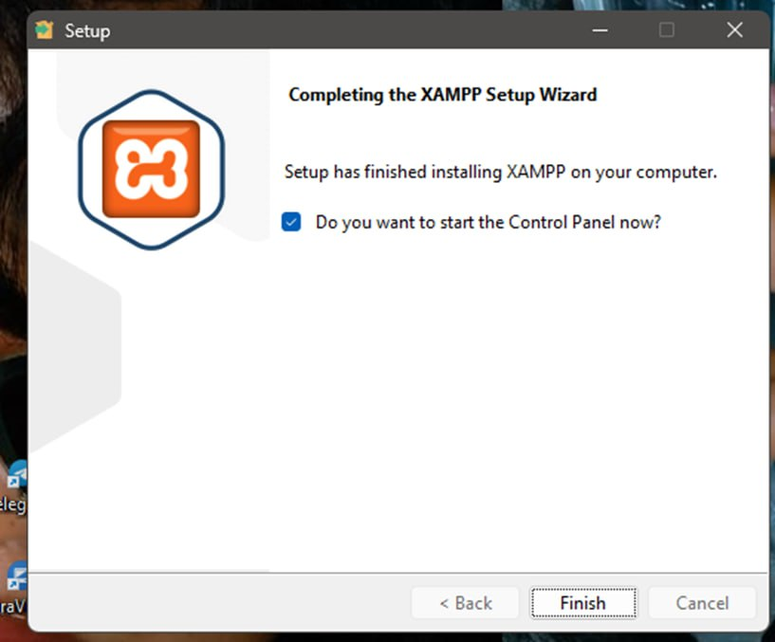
Shows the success in installing XAMPP.It provides Apache and Mysql which l will use in development.
Fig 2 :Apache and MySQL running
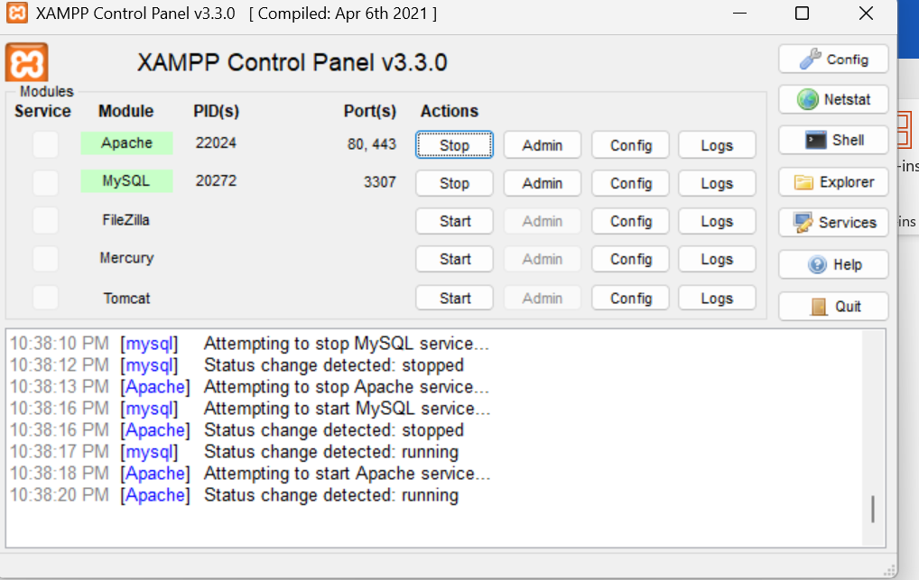
Figure shows that Apache and Mysql are running in the correct ports required in XAMPP control.This provides local server environment.
Fig 3: Localhost test page
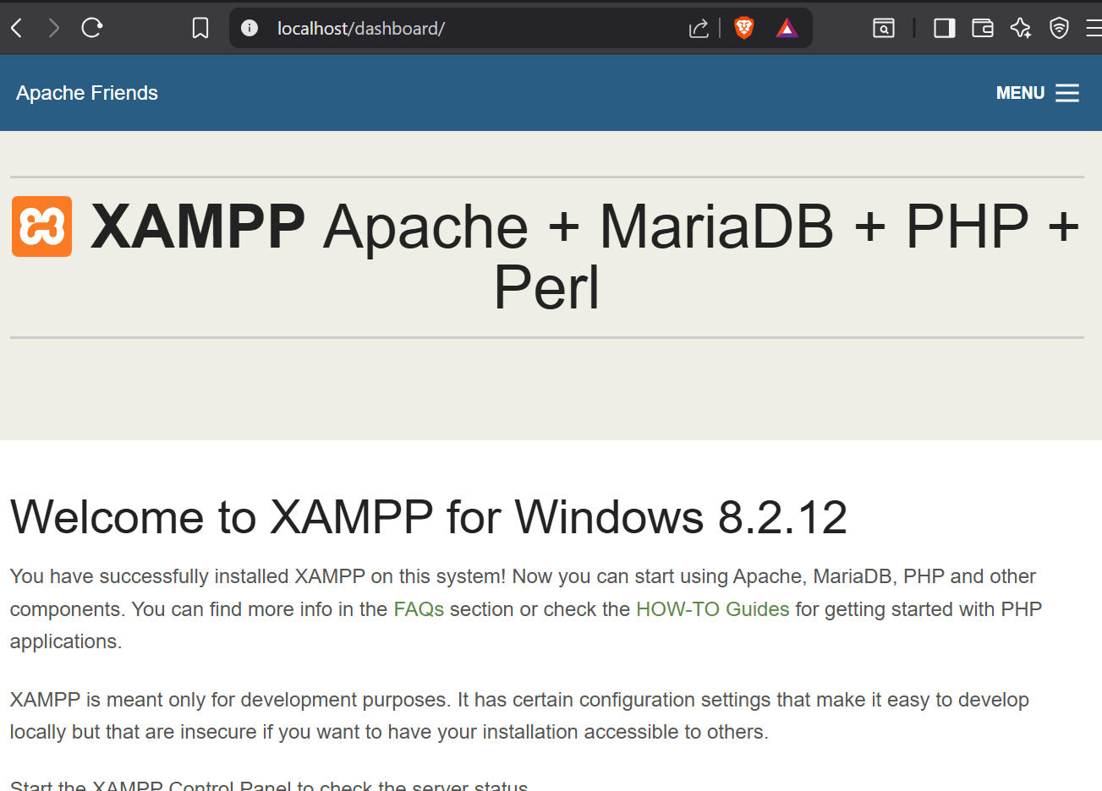
This shows that the localhos server is working correctly by displaying the page in browser
Fig 4: Hello world test

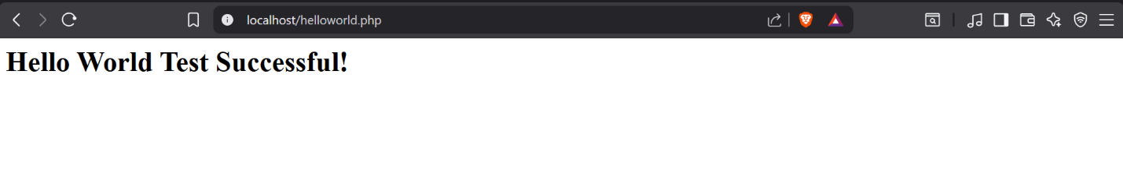This shows a PHP/HTML page used to test that the server can execute and display web pages correctly
Fig 5:Database Connection Test
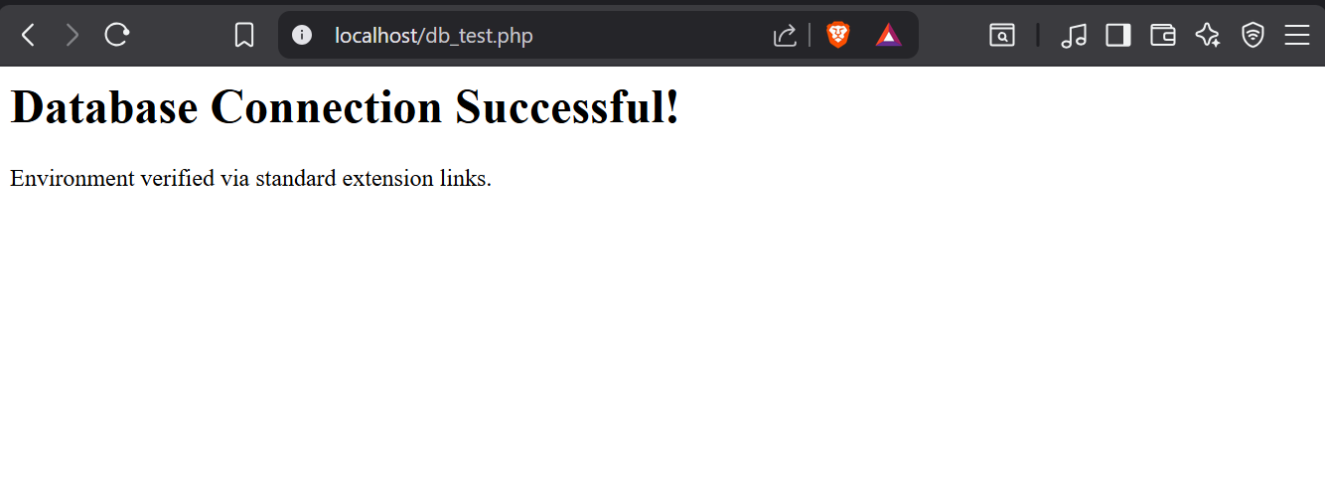
This shows successful connection of PHP and MySQL showing that Apache and MySQL were properly configured in XAMMP.
Technologies PHP + MySQL
Challenges – Connection of the database.The server was using an advanced authentication plugin(auh_gssapi_client)that PHP’s built in tools kept blocking.

Week Two: Wireframes and GUI Design
Fig 1: Wireframe (login /Homepage)Graphic representation of how the system homepage is what the users get int contact with when they search up the site.
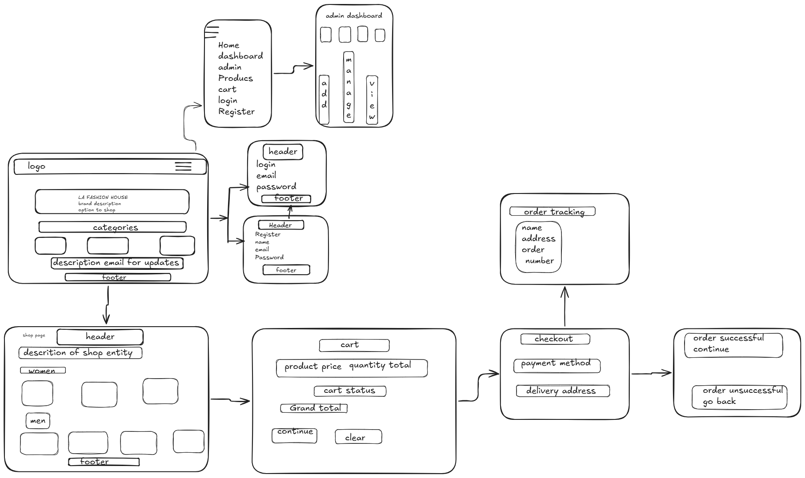
This shows the seps taken by users when using the system and of how different sessions occur. It is a blueprint of how the system will operate.

Fig 2: Dashboard Layout Design
Graphic representation of the system .Rough presentation of how the dashboard should appear and the interaction of components.

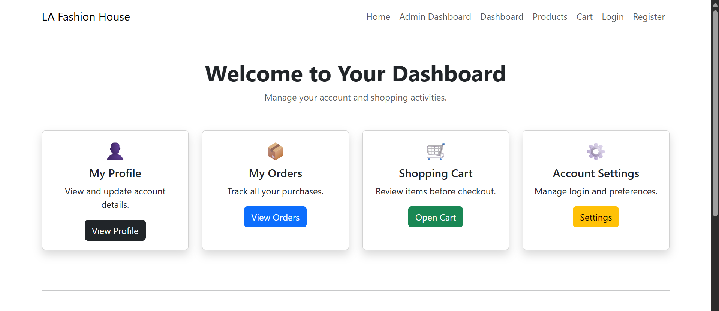This demonstrates how different sections are arranged for user usability and access

Week 3: JavaScript and PHP Basics
Fig 1: JavaScript Form Validation
In the figure it shows the requirement to add a field inorder to move to the next stepof registration.
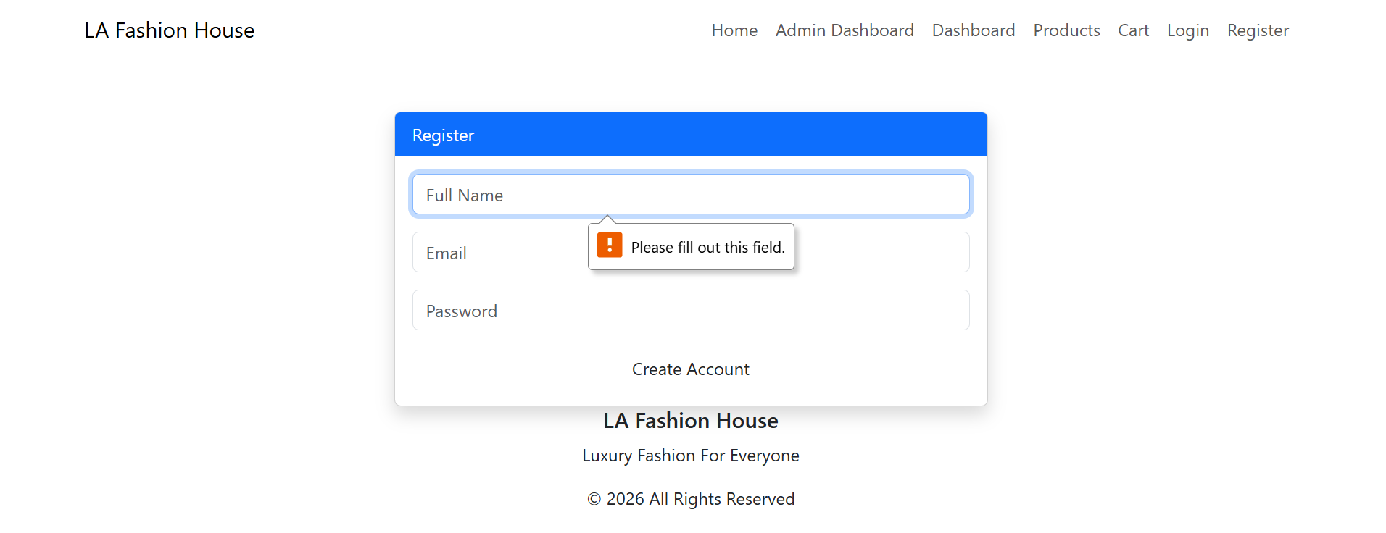
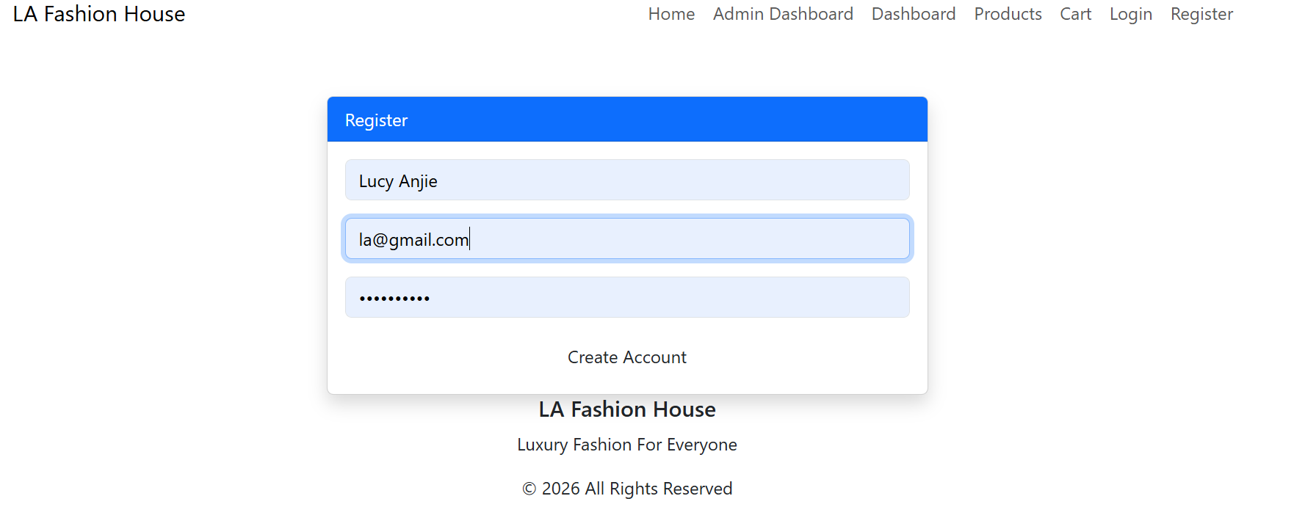
This shows that validation prevents users from submitting incorrect or empty forms.
Fig 2: Password Strength Checker
Using password checker it shows the system is able to advice on better passwords for security purposes to users and also enables one to understand when a breach is made the password was the problem.
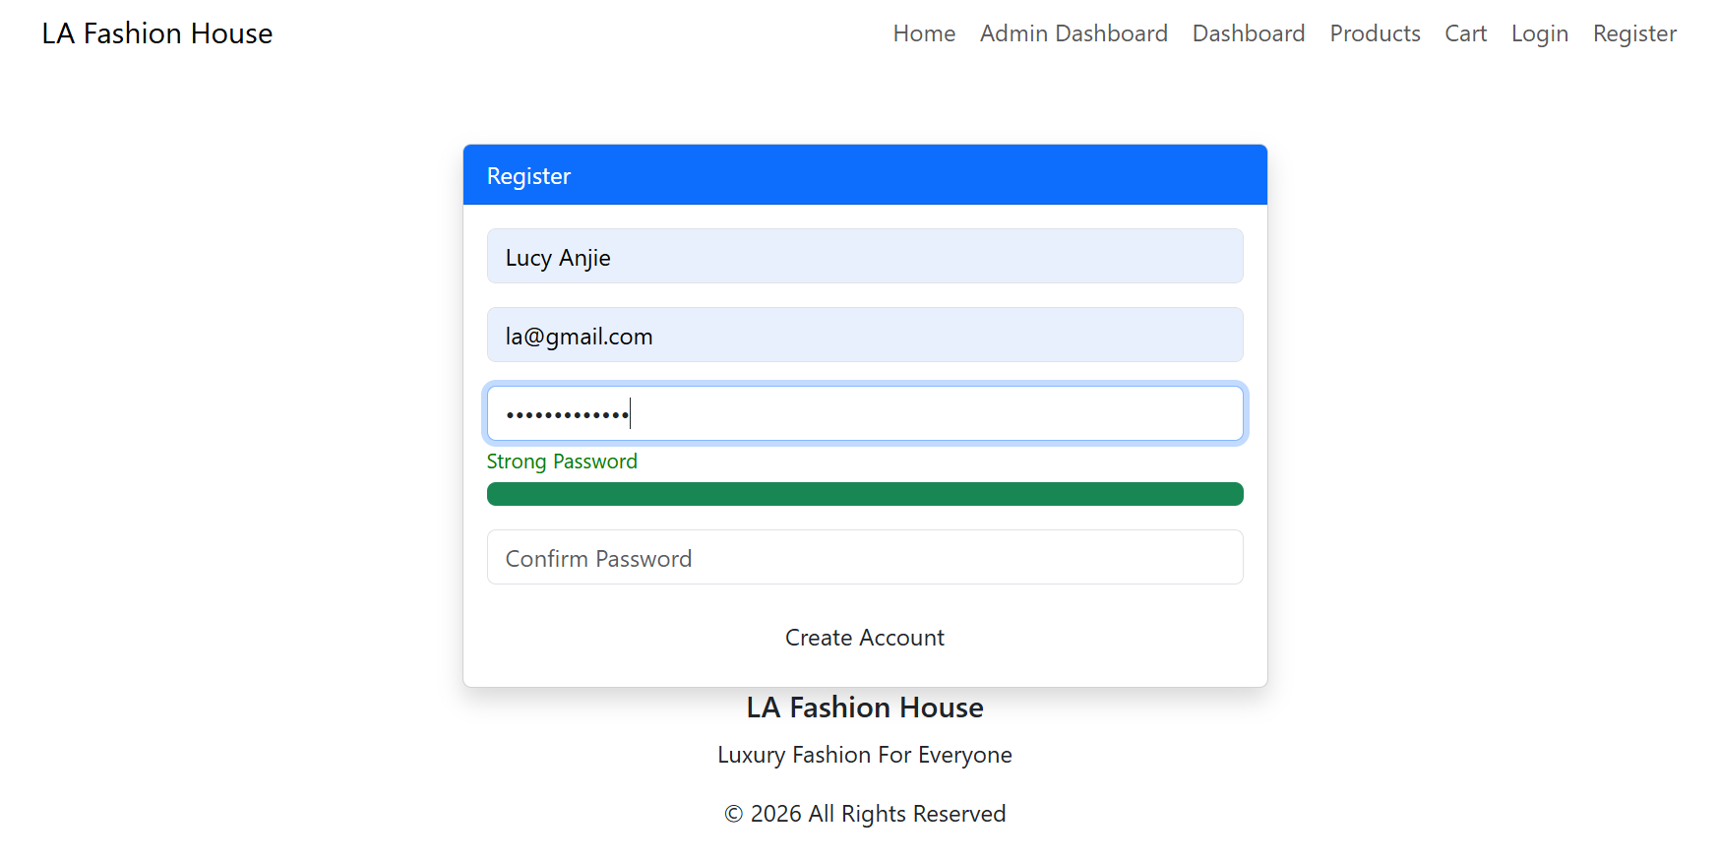
This shows the user has entered a strong password that is safe.
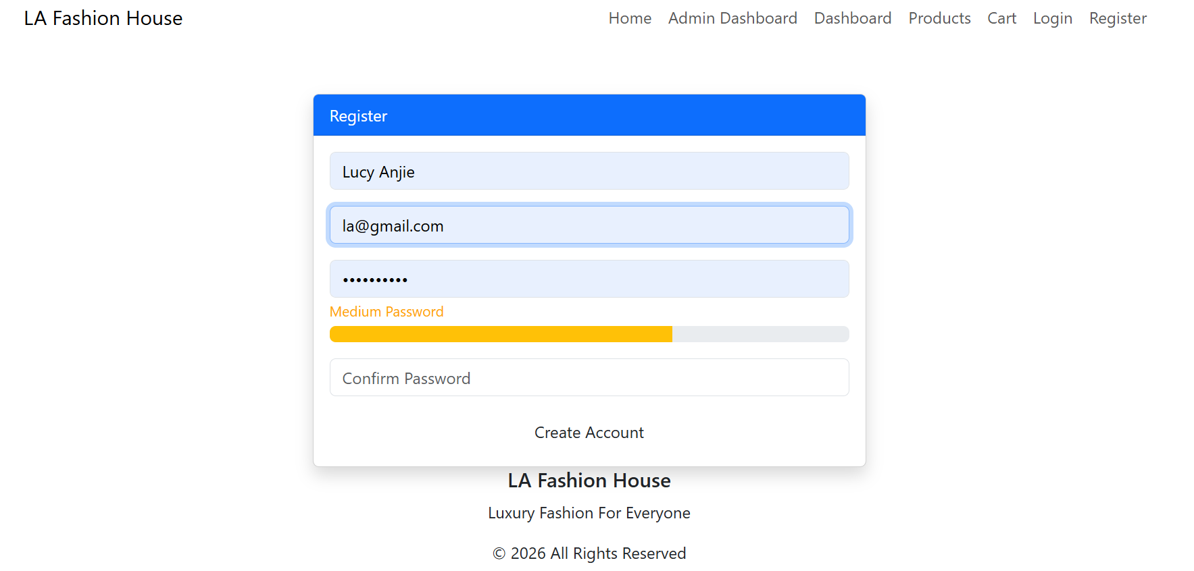
Shows th user is using a medium password which is actually vulnerable.
Fig 3: PHP Syntax Practice
Validates that the system adheres to preferred syntax method or lines in place
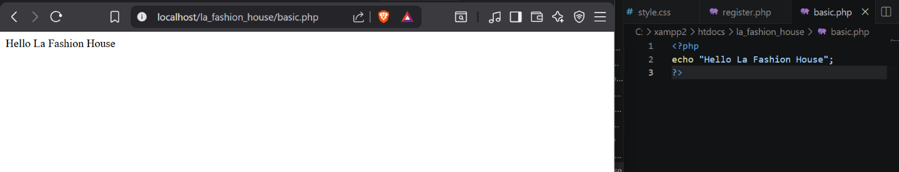

Fig 4: Database Connection Script
The connection between php and mysql .Stands to represent how database where data is stored(phpmyadmin) for the specific site ith tables .
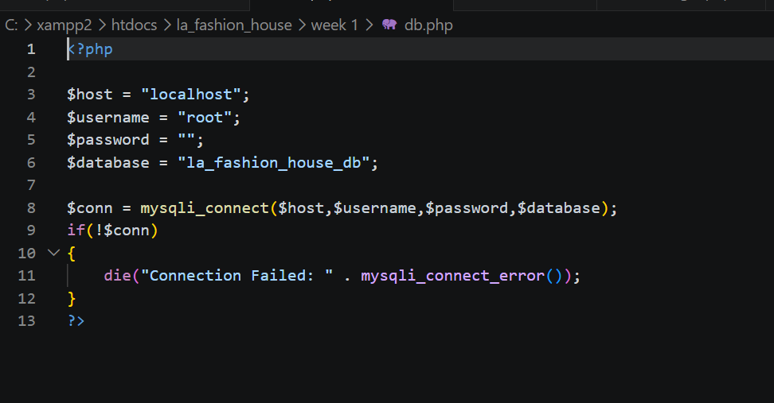
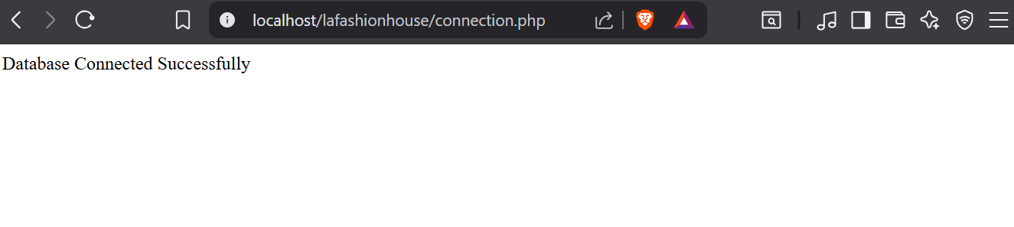One challenge I faced was fixing localhost and 404 errors (not found) while testing PHP files using XAMPP. I solved this by learning the correct folder structure inside the htdocs directory and using the correct localhost URLs.Technologies used HTML,CSS,Javascript,PHP,MySQL,XAMPP

Week 4: Simple PHP Concepts
Fig 1:Login form screenshots
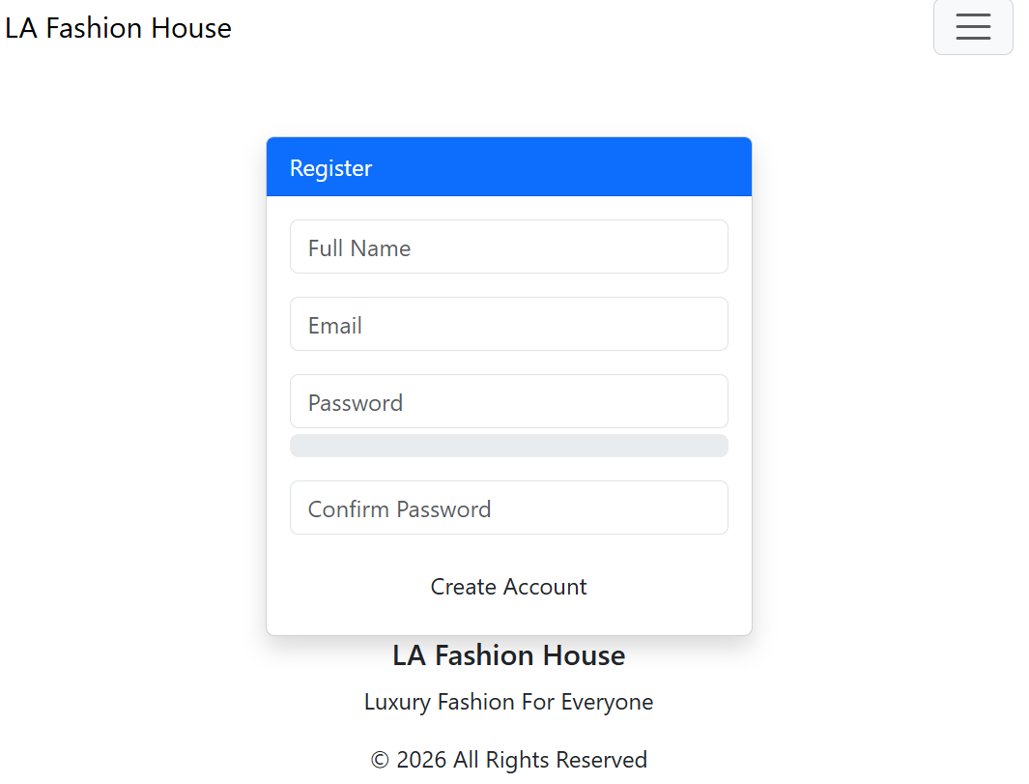
This shows the user registration form where users entre their details to be able to log in the system

Fig 2:Data submission to database
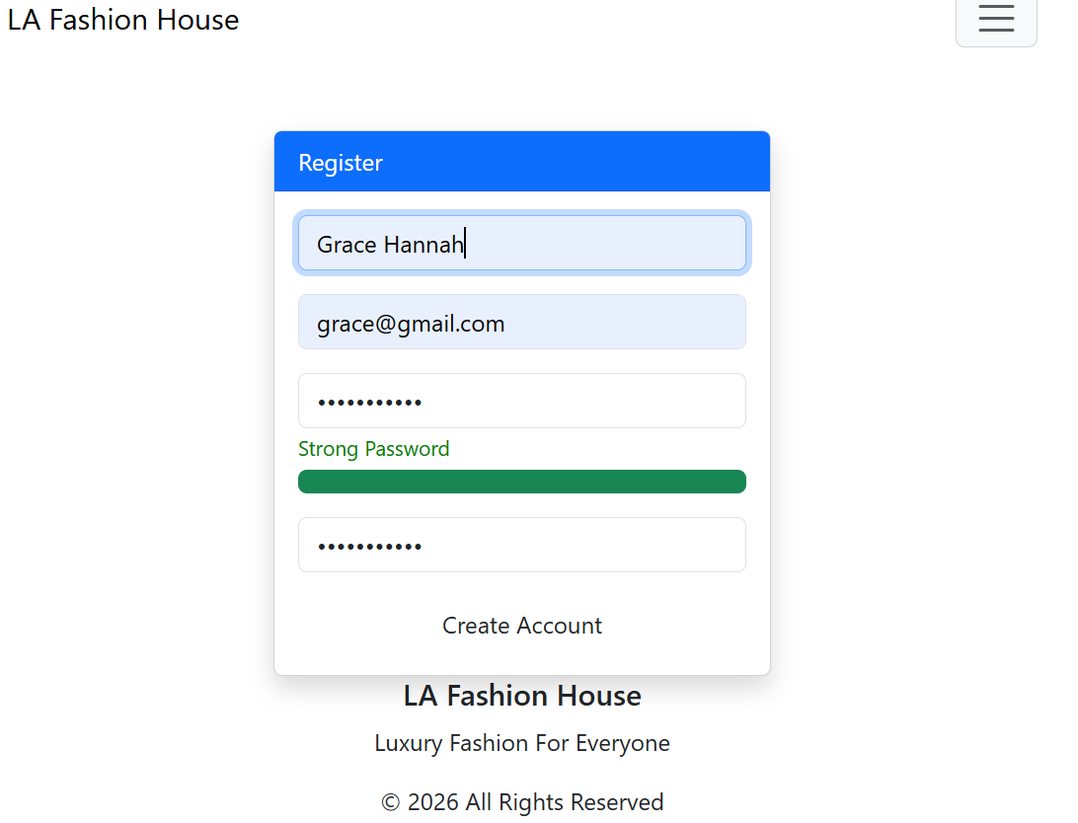
This shows how user data is submitted from the registration form and stored in the MySQL database using PHP.

Fig 3: PHP processing screenshots
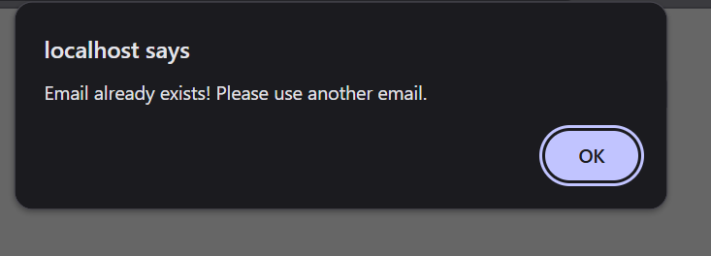
This shows that the email inserted already exixts on the daabase and the user is required to use a different one or login.
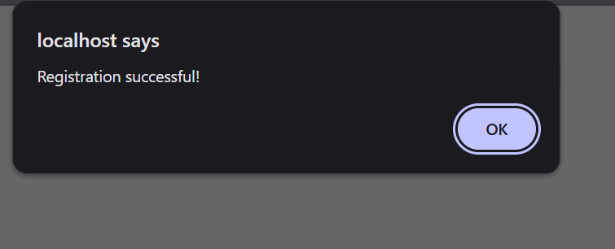
Shows that a user can register to the web store register form and their data sent to the database for storage.
Fig 4: Log in system
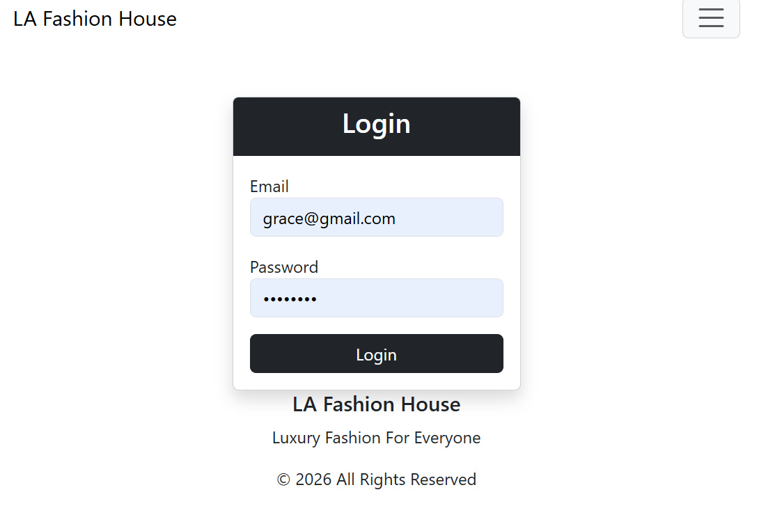
This shows how the system works when users enter their email and password.The system retrieves the user record based on the enmails and prepares for authentication.
Fig 5 :Dashboard access

This shows the user is given access to the page containing the products on sale in the store .After verification the user is given access and redirected.
Tools and technologies used PHP,MySQL,XAMPP,HTML,phpMyAdmin

Week 5: Database components and Crud operations
fig 1:Create your database (phpMyAdmin)
I created a new daabase to support the application.It consists of multiple tables such as cart,order,product and users.
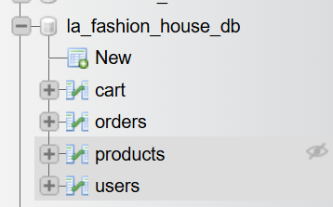
Fig 2: Create users table
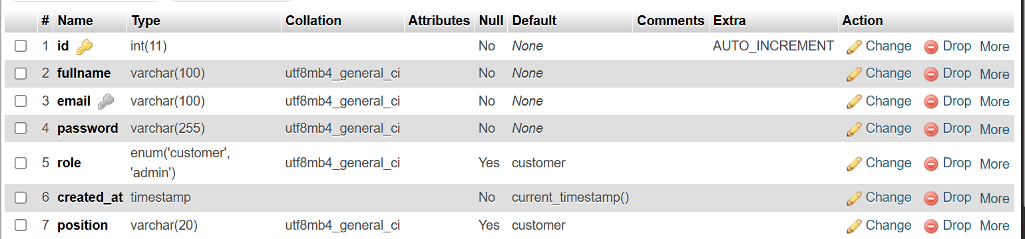
Using an SQL query l created the table which allows new data to be added in the system.This connects to the registration form which users access to register.
Fig 3:Insert sample data
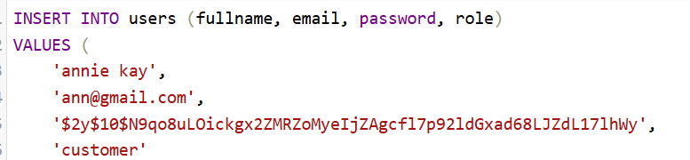
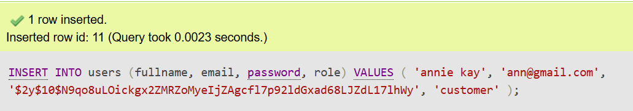
This shows the INSERT operation.I added a new user as a customer to the system.The data entered entered by a user qis collected through a form and stored in the database using SQL INSERT statement.
Fig 4: Connect PHP to database
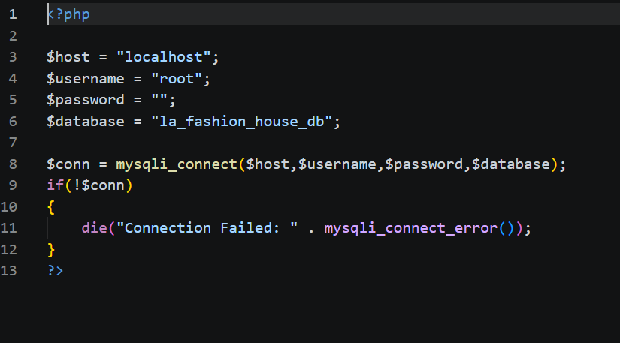
This shows the file that allows communication between the application and the database eg when a user registers.It ensures data can be stored,reviewed and manipulated dynamically.
Fig 5:READ (to display users)
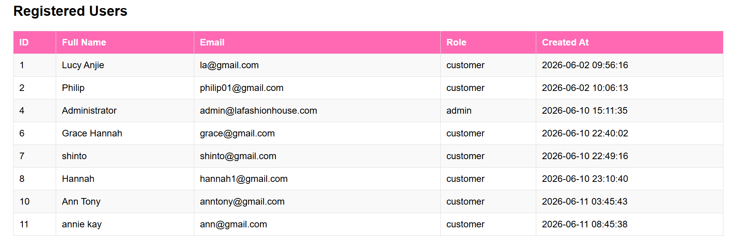
The read function operates correctly by fetching data from the database and displaying it.
Fig 6:UPDATE Data
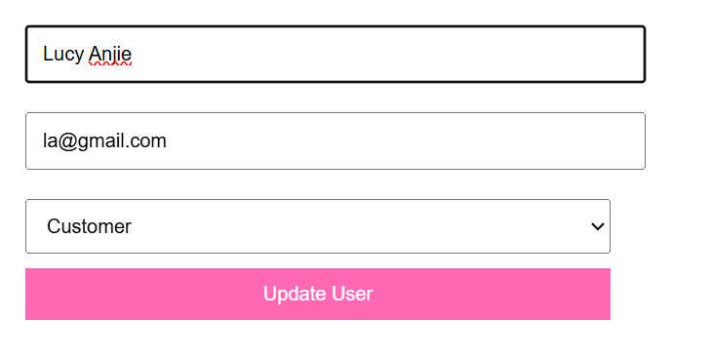
This shows a users previous role as a customer before changes.
After updating the role the user can now access the platform as an admin.
Fig 7:Delete data
This shows a column that exists before in the list on clicking delete the page will direct the user to confirm and once they confirm it is deleted.
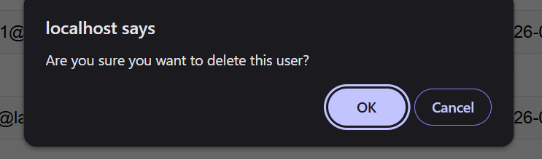
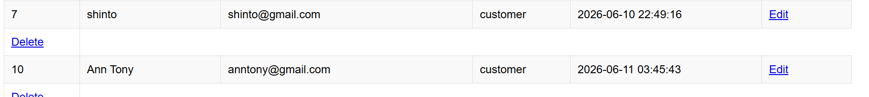
Shows column 8 is deleted.

